Running PublicTransportAllocator scripts
Public Transport Allocator is a small GeoDMS model created to simulate the development of public transport networks in cities, using straightforward economic rules of transport demand and investment costs, fine resolution population grids, and criteria including a minimum % of the city’s population having at least one public transport connection in their grid cell. It uses three data sources:
- A fine resolution population grid (currently, the GHSL 1km population grids 2015);
- A shapefile with city boundaries (currently, the FUA shapefile produced by the GHSL team);
- A list of cities for which results need to be obtained.
The script runs with certainty on all GeoDMS versions v7.130 and above. It is advisable to use a 64 bit version of GeoDMS and to use GeoDMS 7.176 or higher, in order to fully use the parallel processing support offered for Dijkstra shortest path applications.
Results can be obtained through the GUI or through a DOS batch file that triggers the computation process externally. Example batch files are provided with the configuration.
Copy the configuration and source data on a convenient location
On the PC on which the scripts are developed, the scripts and source data have been organized on the G:\ drive. Scripts were put in G:\Projdir\PublicTransportAllocator, sourcedata in G:\SourceData\PublicTransportAllocator. The following structure was followed:
Base folder | Subfolder | Description
 | \Batch | Batch file examples
G:\ProjDir\PublicTransportAllocator | \Cfg | Scripts (.dms)
 | \Docs | Documentation
G:\SourceData\PublicTransportAllocator\data | \FUAs | FUA shapefile
 | \Population | Population grid

NOTE: For PCs on the JRC green network, all DOS batch files need to be run from a dev folder in the root of the hard drive – for example, G:\dev\getGlobalFUAresults.cmd
Set up the configuration
Install GeoDMS. Make sure the options are set correctly (see Figure 1). In particular LocalDataDir, SourceDataDir, Parallel Processing 1 and PP2. The LocalDataDir is where temporary and result files will be stored. SourceDataDir is where the data of various projects is stored (ie G:\SourceData). Do not forget to close GeoDMS completely, then reopen it again, to ensure the settings are stored properly.
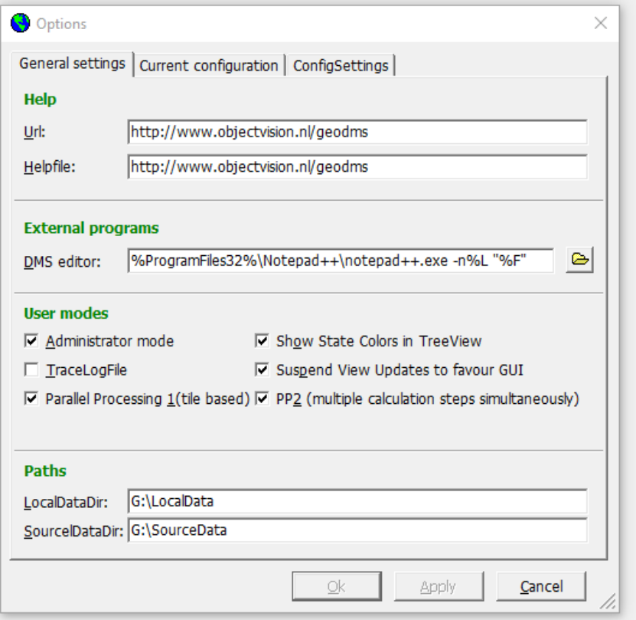
Figure 1: Example GeoDMS options
Set up the batch file
The batch file triggers the computation of networks for all selected cities. Three lines need to be changed, dependent on computer configuration, to make the batch files run. Those are the following three lines:
set pf="Program Files"
set config=G:\ProjDir\PublicTransportAllocator
set geodmsversion=GeoDMS7182
In the first line, the folder name for the 64 bit program files folder in Windows need to be given. It is assumed those are on the C:\ drive, so that the current definition of pf refers to C:\Program Files
In the second line, the folder name for the scripts need to be given. Essentially this refers to the base folder (as in the table on p.1) where the scripts are found.
In the third line, the used GeoDMS version needs to be given. Again, see recommendations for GeoDMS versions on the first page
Test the configuration
To test whether the configuration works, open GeoDMS and load the main.dms file to be found in the \cfg folder. To see whether the data loads properly, go to /SourceData/FUA, then double click Geometry. If everything works, the map below (see Figure 2) should be visualized. If something has gone wrong in the file references, the program will throw an error and mark the FUA element in red.
If the program throws an error while trying to load sourcedata, the SourceDataDir is not set correctly (see set up the configuration) or there is something wrong with the data in the folder.
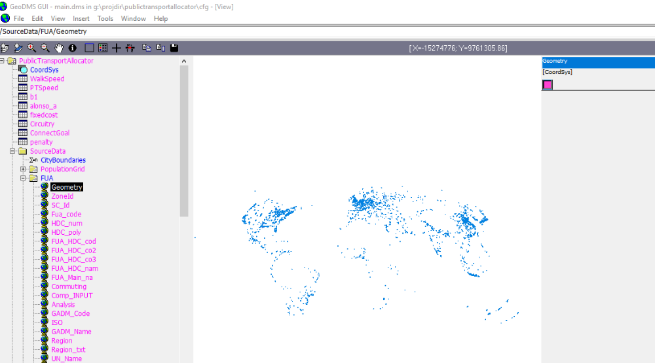
Figure 2: Sign the data is loaded correctly
It is probably a good idea to repeat the check for the other data source, namely PopulationGrid. Open the ReadData element in it. If all goes well the grid map should visualize as completely blue.
Run the configuration
If the source data could be loaded correctly, it is probably best to start the DOS batch file. To do so just double click the batch file where it is located
REMINDER: For PCs on the JRC green network, all DOS batch files need to be run from a dev folder in the root of the hard drive – for example, G:\dev\getGlobalFUAresults.cmd
Note that the computation times may differ much per city ran. Relatively small FUAs (73: Hong Kong, 1385: Kinshasa) will probably finish in a couple of hours – very large FUAs (5129: Tokyo) might take multiple days.
Check the results
The script generates one result polyline shapefile per each selected FUA. This shapefile is put in the GeoDMS set LocalData folder. By means of example, on the development PC Kinshasa has been stored as G:\LocalData\PublicTransportAllocator\results\FUA_1385_net.shp.
The shapefiles are stored in the Mollweide global projection system (similar to the FUA shapefile and population grid).
The shapefiles need to be checked for plausibility and for potential problems with meeting the percentage population connected. Both aspects can be checked in a GIS – ideally with a background map to help orientation. The second check is the easiest – if the maximum value in the ‘step’ field is below 599, the population connected criterion is presumably met. This field indicates the chronology of additions to the simulated network.
To check plausibility, open the shapefile, and verify if connections are more in densely populated areas and generally follow clusters of population. An example for Hong Kong is given below. This result can be considered plausible.
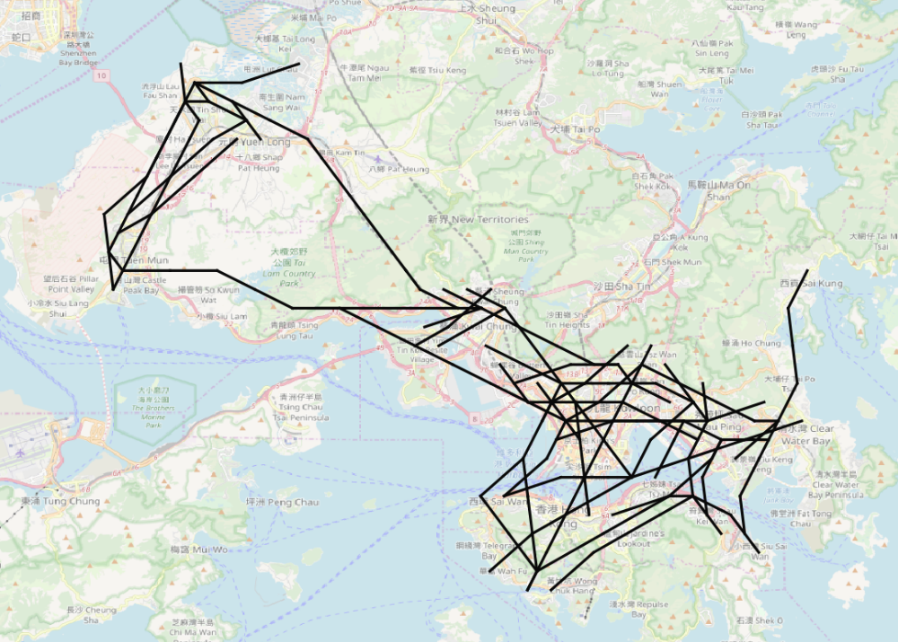
- High density in densest area
- Single lines to connect cores
- Connections in the water are not a problem, may be ferries or subways

Note that waterways or mountain ranges are not considered in the simulation and therefore should not be considered relevant factors when judging whether the results are plausible, given the limited inputs in the simulation.

